Online Airline Reservation System

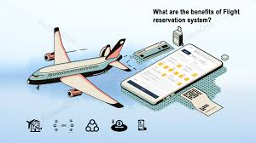

1. **Aim: -**

The Airline Reservation System (ARS) is a software application which aims to assist an airline with transactions related to making ticket reservations, which includes booking, reserving, cancelling and rescheduling tickets. From the viewpoint of the airlines the system provides the following: -

* 1. The system should minimize repetitive work done by the system administrator and reservation clerks.
  2. The system should maintain customer information in case of emergency.
  3. The system should minimize the number of vacant seats on a flight and maximize flightcapacity utilization.
  4. The system should reduce effort and frustration for travellers in scheduling a trip,especially by reducing the search effort for the flight they need to take.
  5. The system should make it easy for travellers to check the ticket status or make changes to their trip.

1. **Entities and Attributes: -**
2. Passenger (customer): The person who is booking

## P_ID

* 1. First_name:
  2. Last_name
  3. Passport_no
  4. P_age
  5. E_mail
  6. Residence
  7. Phone_no
  8. Relative_phone_no

1. Journey Details: Details of journey

## Journey_ID

* 1. Meal
  2. Other_info

1. Ticket Details: Details of ticket

## Ticket_no

* 1. Journey_ID
  2. Fair
  3. Class
  4. Status

1. Schedule: Details of journey schedule

## Schedule_ID

* 1. Depar_location
  2. Arri_location
  3. Depar_time
  4. Arri_time
  5. Journey_ID

1. Flight Details: Details of flight

## Flight_no

* 1. Journey_ID
  2. Schedule_ID

1. ER Diagram: -

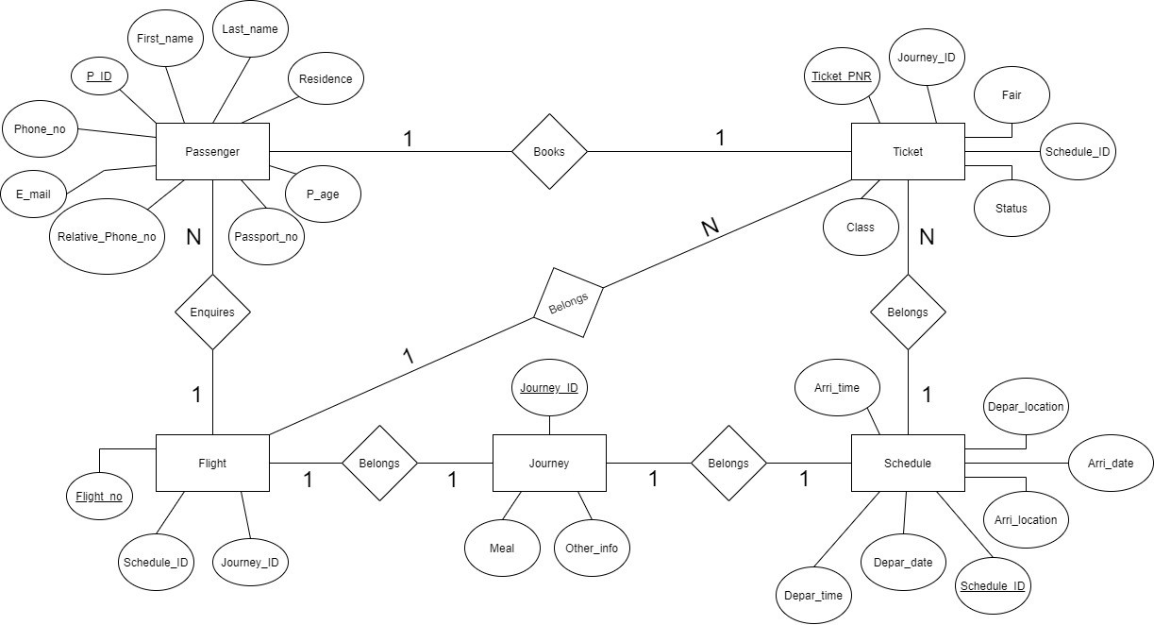

# Relational Schema: -

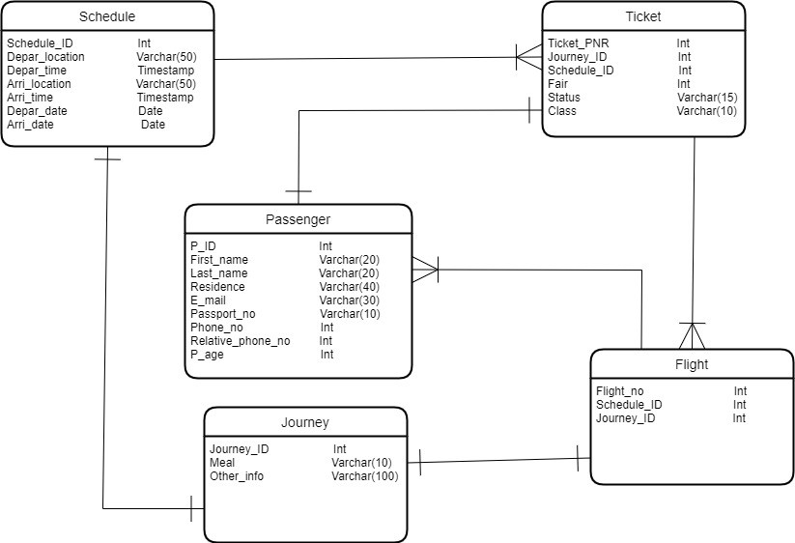

1. Implementation on SQL Server: -

# Code for creating tables on SQL Server: -

Create table passenger (P_ID numeric(10) not null,

First_Name Varchar(20) not null, Last_Name Varchar(20) not null, P_age numeric(3),

Residence Varchar(40) not null,

Phone_no Numeric(10) not null, Relative_phone_no numeric(10), Email_Address varchar(20) not null, Passport_no varchar(10) not null, Ticket_PNR varchar(10),

constraint passenger_up unique (passport_no), constraint passenger_pk primary key (P_ID)

);

Create table Schedule (

Schedule_Id numeric(10) not null, Depar_location varchar(50) not null, Depar_date Date not null, Depar_time time not null, Arri_location Varchar(50) not null, Arri_date date not null,

Arri_time time not null,

constraint schedule_pk primary key (schedule_ID)

);

Create table Journey (

Journey_Id numeric(10) not null, Meal varchar(10) not null, Other_info Varchar(100),

constraint journey_pk primary key (Journey_ID)

);

Create table Ticket (

Ticket_PNR Varchar(10) not null, Journey_Id numeric(10) not null, Schedule_ID numeric(10) not null, Fair int not null,

Class Varchar(10) not null, Status Varchar(15) not null,

constraint ticket_pk primary key (ticket_PNR)

);

Create table Flight (

Flight_no varchar(5) not null, Schedule_id numeric(10) not null, Journey_id numeric(10) not null,

constraint Flight_pk primary key (flight_no)

);

# Code for Inserting Values into the table: -

INSERT INTO Passenger

VALUES (6458972345,'Vaibhav','Rawal',17,'Delhi',5674328896,6314895627,'vaibhav@gmail.com','D568749125','PNQ001');

INSERT INTO Passenger

VALUES (6458972346,'Ashutosh','Sareen',18,'Delhi',6314895627,2467831435,'ashu@gmail.com','E364785521','PNQ002');

INSERT INTO Passenger

VALUES (6458972347,'Vijay','Sahu',30,'Jaipur',2467831596,9875546258,'vijay@gmail.com','F578942451','PNQ003');

INSERT INTO Passenger

VALUES (6458972348,'Raghav','Yadav',35,'Indore',6489521374,9865421374,'raghav@gmail.com','G246458713','PNQ004');

INSERT INTO Passenger

VALUES (6458972349,'Rishab','Mathur',30,'Mumbai',9547623815,9658423614,'rishab@gmail.com','H341578426','PNQ005');

INSERT INTO Schedule

VALUES (201, 'Delhi', '2021-10-25', '06:30:00', 'Dubai', '2021-10-25','9:00:00');

INSERT INTO Schedule

VALUES (202, 'Dubai', '2021-10-26', '10:30:00', 'Delhi', '2021-10-25','12:00:00');

INSERT INTO Schedule

VALUES (203, 'Delhi', '2021-10-26', '06:30:00', 'New York','2021-10-27','2:00:00');

INSERT INTO Schedule

VALUES (204, 'New York', '2021-10-28', '12:30:00', 'Delhi','2021-10-29','14:00:00');

INSERT INTO Schedule

VALUES (205, 'Delhi', '2021-10-30', '15:30:00', 'Mumbai', '2021-10-30','17:00:00');

INSERT INTO Journey

VALUES (513, 'YES', 'Require Wheelchair');

INSERT INTO Journey

VALUES (514, 'NO', NULL);

INSERT INTO Journey

VALUES (515, 'YES', 'Require Wheelchair');

INSERT INTO Journey

VALUES (516, 'NO', 'Require Wheelchair');

INSERT INTO Journey

VALUES (517, 'YES', NULL);

INSERT INTO Ticket

VALUES ('PNQ001',513, 201, 25000,'ECONOMY','CONFIRMED');

INSERT INTO Ticket

VALUES ('PNQ002', 514, 202, 55000,'BUSINESS','CONFIRMED');

INSERT INTO Ticket

VALUES ('PNQ003', 513, 203, 85000,'FIRST','CONFIRMED');

INSERT INTO Ticket

VALUES ('PNQ004', 515, 204, 20000,'ECONOMY','NOT CONFIRMED');

INSERT INTO Ticket

VALUES ('PNQ005',517, 205, 25000,'ECONOMY','NOT CONFIRMED');

INSERT INTO Flight

VALUES ('AI407',201,513);

INSERT INTO Flight

VALUES ('AI408',202,514);

INSERT INTO Flight

VALUES ('AI409',203,516);

INSERT INTO Flight

VALUES ('AI410',202,517);

INSERT INTO Flight

VALUES ('AI411',205,514);

select * from passenger;

select * from schedule;

select * from Ticket;

select * from Flight;

select * from Journey;

Output: -

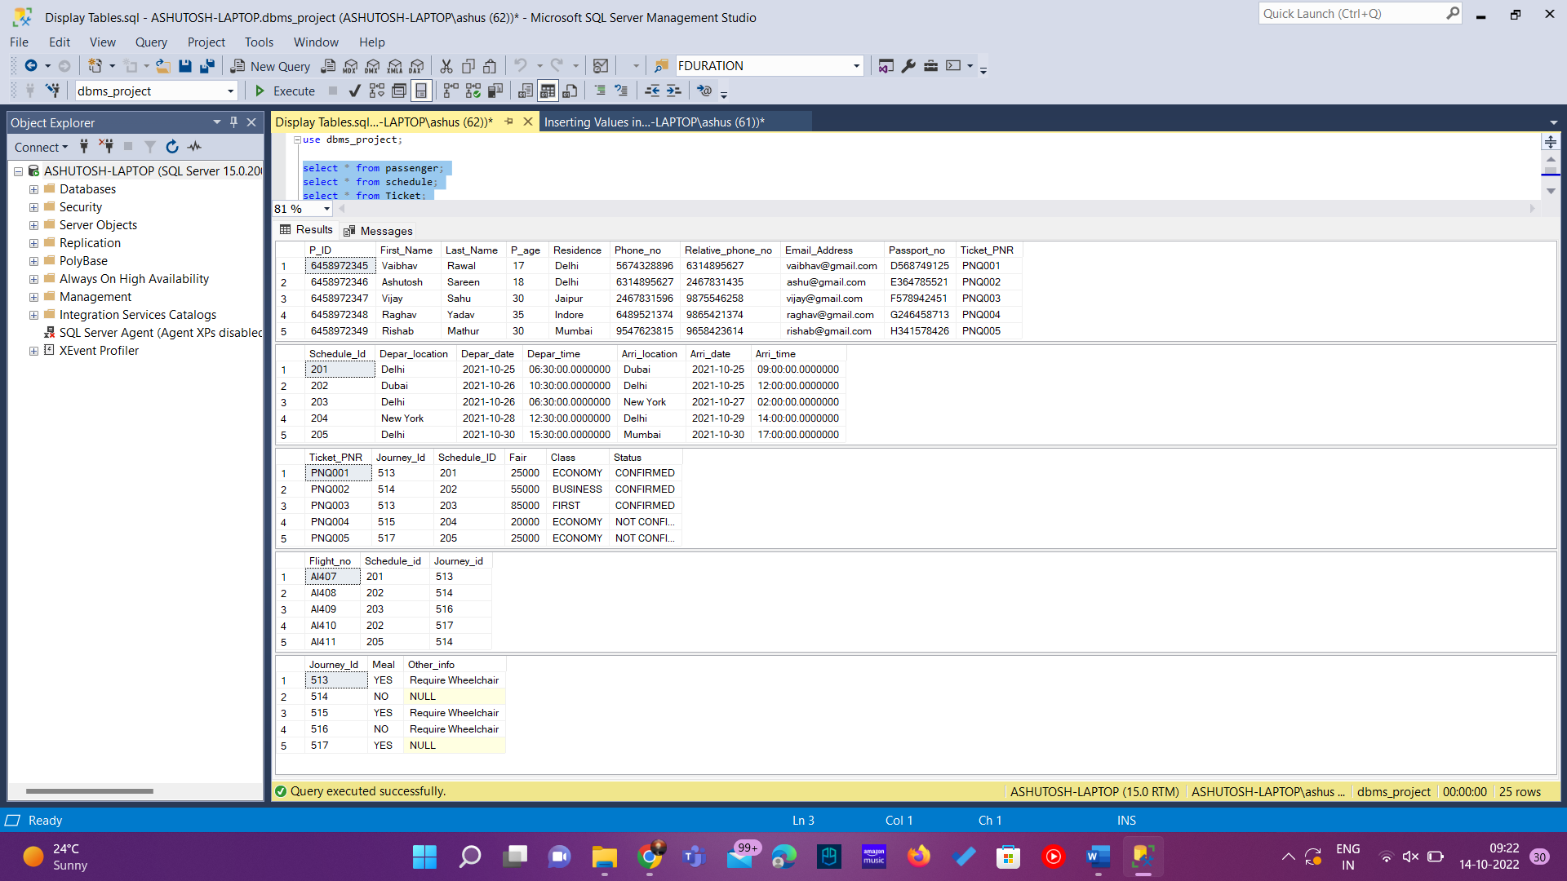

# Queries related to database: -

1. Find the information of the passengers who are below 18 years.

select * from passenger where p_age < 18;

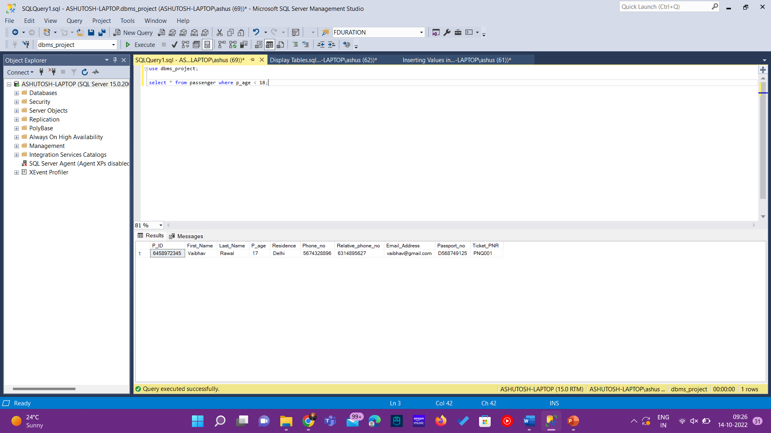

1. Find the departure time and date of ticket PNR = PNQ002. select depar_date, depar_time from schedule where schedule_id=(select schedule_id from ticket where ticket_PNR='PNQ002');

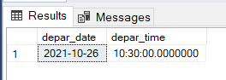

1. Find the ticket_pnr whose ticket is not confirmed.

select ticket_pnr from ticket where status='NOT CONFIRMED';

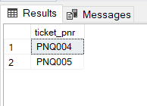

1. Show the passenger’s name along with the class in which they will travel. select passenger.First_Name as "Passenger Name", ticket.class as "Class" from ticket inner join passenger on passenger.Ticket_PNR=ticket.ticket_PNR;

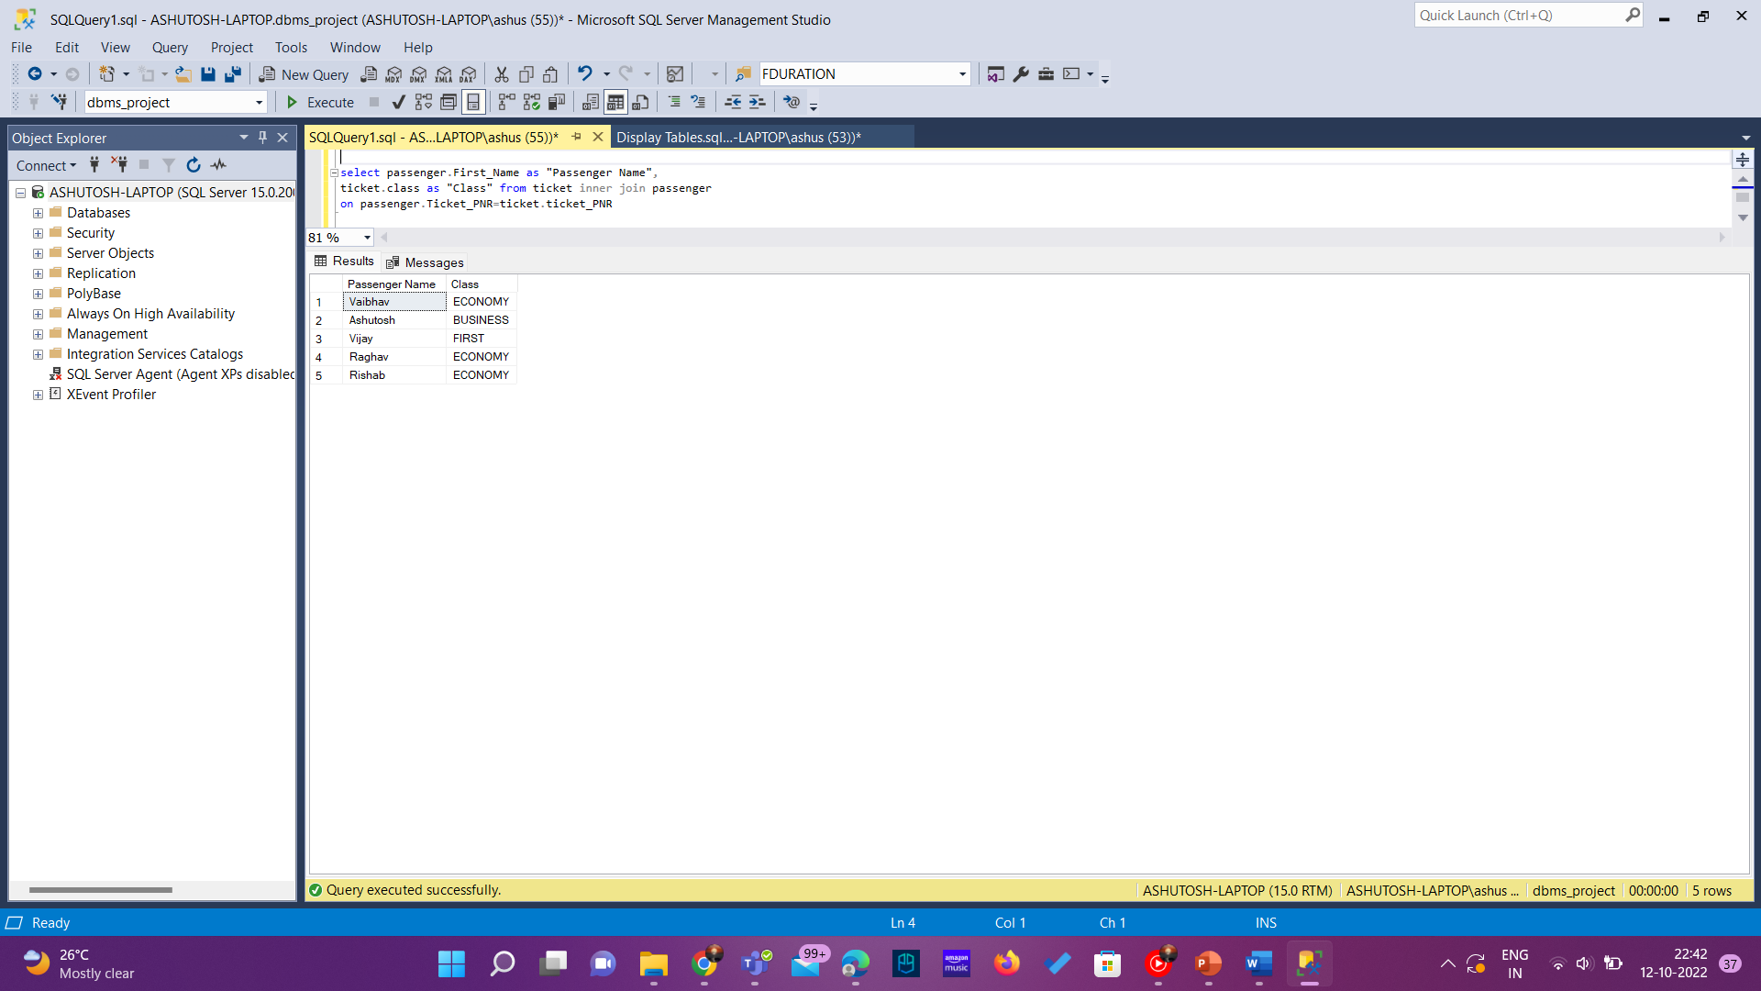

1. Find the name of passenger who bought the costliest ticket.

select passenger.First_Name as "Passenger Name" from passenger inner join ticket on ticket.ticket_PNR=passenger.Ticket_PNR and ticket.fair=(select max(fair) from ticket);

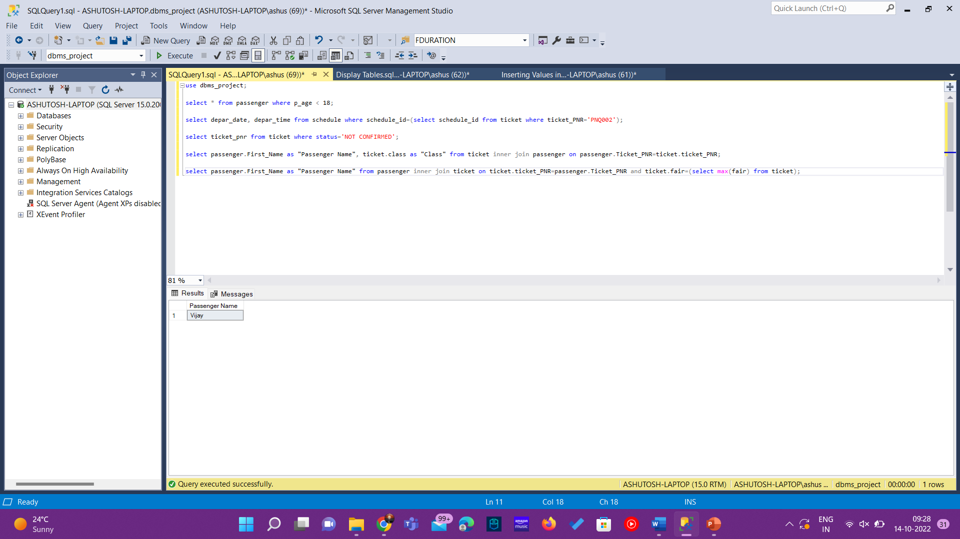

1. Show name, passport number, class and ticket PNR of all the passengers. select passenger.first_name as "Passenger Name", passenger.passport_no as "Passport Number", ticket.class as "Class" ,ticket.Ticket_pnr as "Ticket PNR" from passenger left join ticket on Ticket.ticket_pnr=passenger.ticket_pnr order by class;

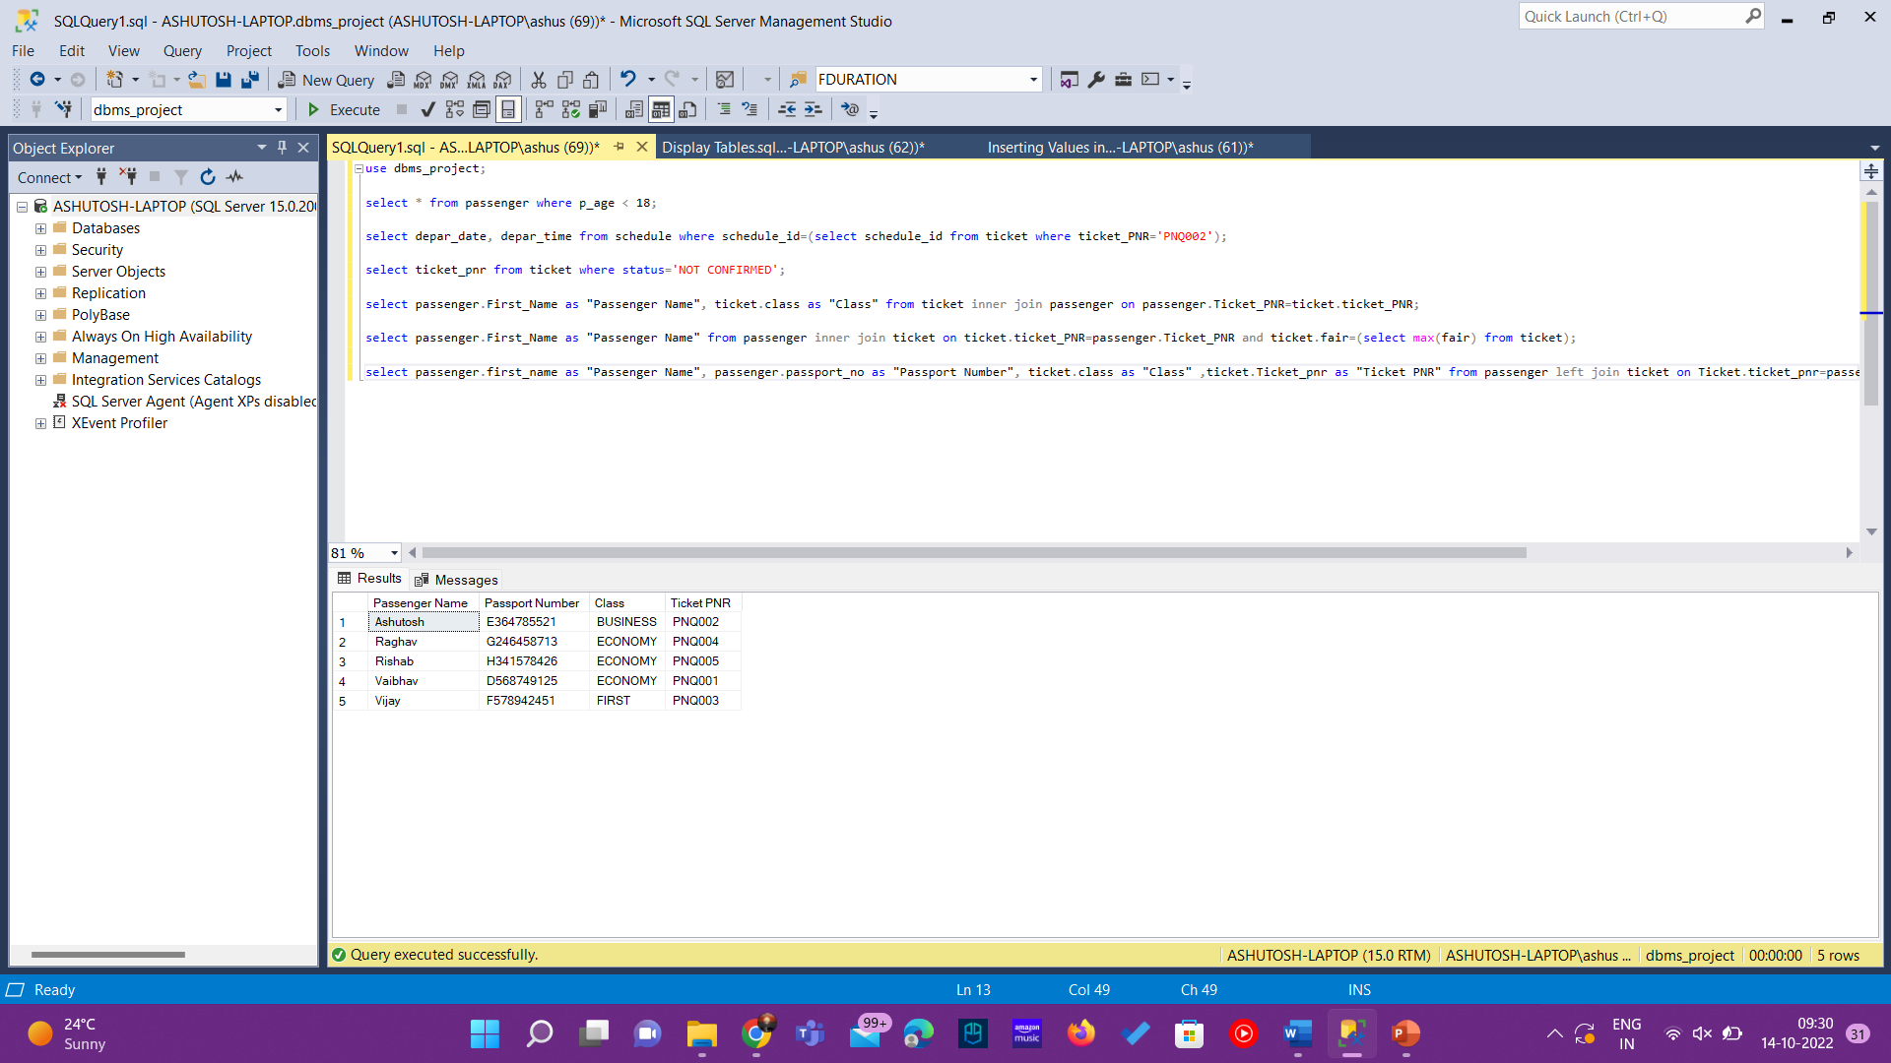

1. List the details of customer whose phone number start with 64.

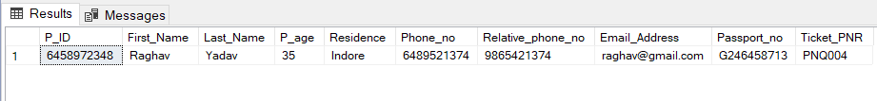select * from passenger where phone_no like '64%';

1. List the details of customers whose relative’s phone number start from 74. select * from passenger where relative_phone_no like '%74';



1. Find the Phone number and name of the passenger who is going to Dubai select first_name as "Name", phone_no as "Phone Number" from passenger where ticket_pnr=(select ticket_pnr from ticket where schedule_id=(select schedule_id from schedule where arri_location='Dubai'));

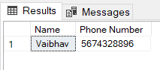

1. Find total number of passengers.

select count(P_ID) as "Number of Passengers" from passenger;

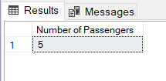

1. Find the flight number going to New York.

select flight_no from flight where schedule_id=(select schedule_id from schedule where Arri_location='New York');

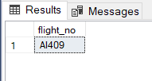

1. Find the Flights coming from Dubai, before 30/10/21.

select flight_no from flight where schedule_id=(select schedule_id from schedule where Depar_location='Dubai' and depar_date<'2021-10-30');

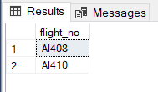

1. Find the names of customers whose name start with letter ‘R’ and end with

‘B’.

select first_name as "Passenger Name" from passenger where first_name like 'r%b';

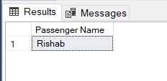

1. Find passengers residing in Mumbai.

select * from passenger where residence='Mumbai';

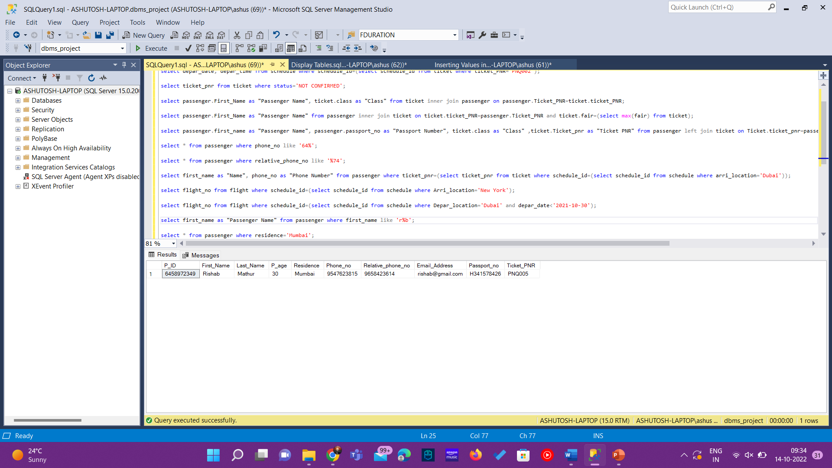

1. Find the ticket PNR of Raghav.

select Ticket_pnr from passenger where first_name='Raghav';

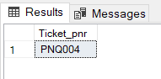

**Prepared By Vijay Sahu**